**Python Formative Assessment 3**

**EDA - Fifa Players Dataset**

**Due on 30th May 24**

**Submitted by Aiswarya Jayaprakash**

Using the below dataset of fifa players dataset. Perform Exploratory data analysis and find the following insights:

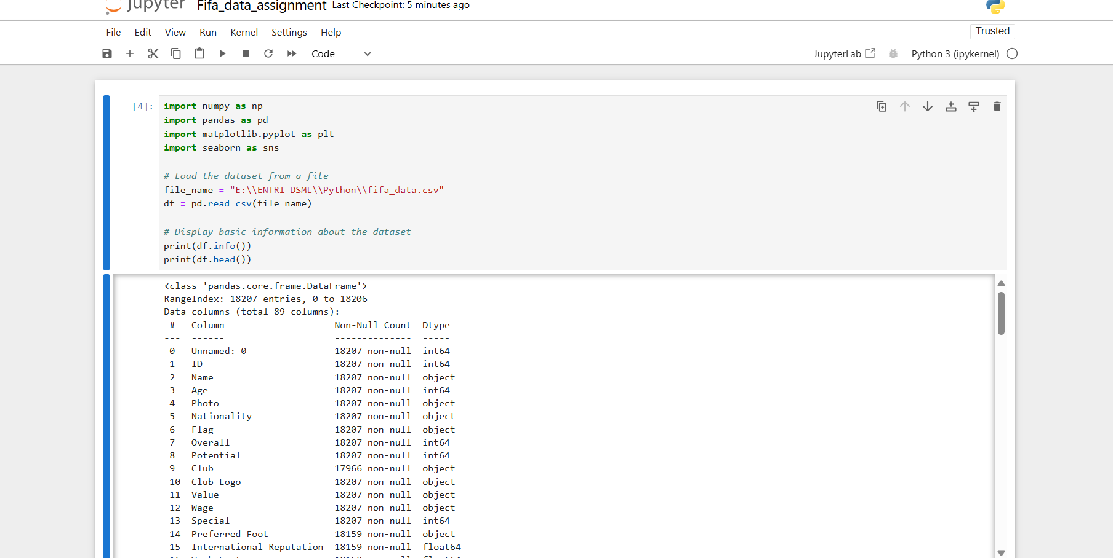

1.Which country has the most number of players (score :1)

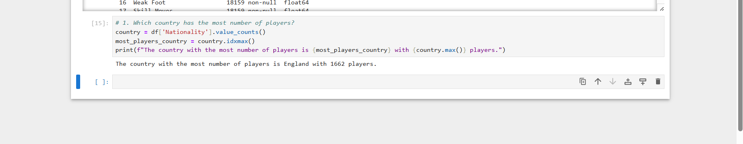

2.Plot a bar chart of 5 top countries with the most number of players. (score :1)

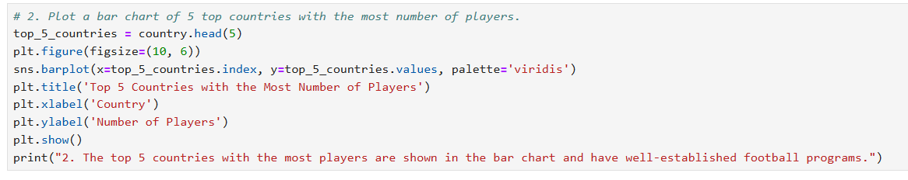

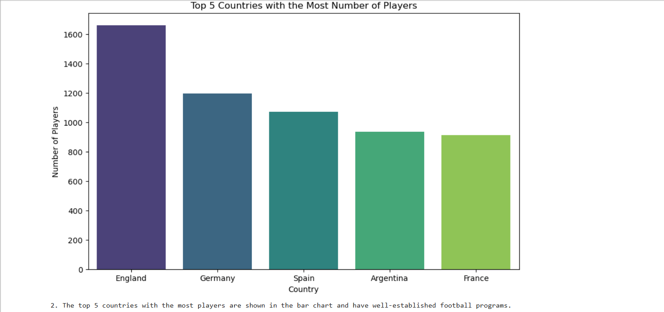

3.Which player has the highest salary? (score :1)



4.Plot a histogram to get the salary range of the players. (score :1)

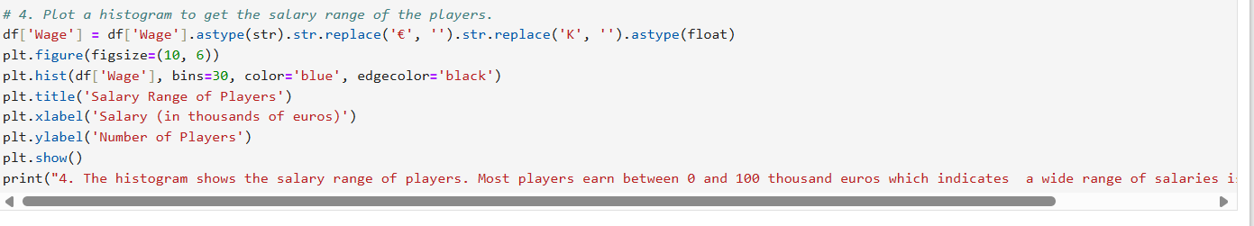

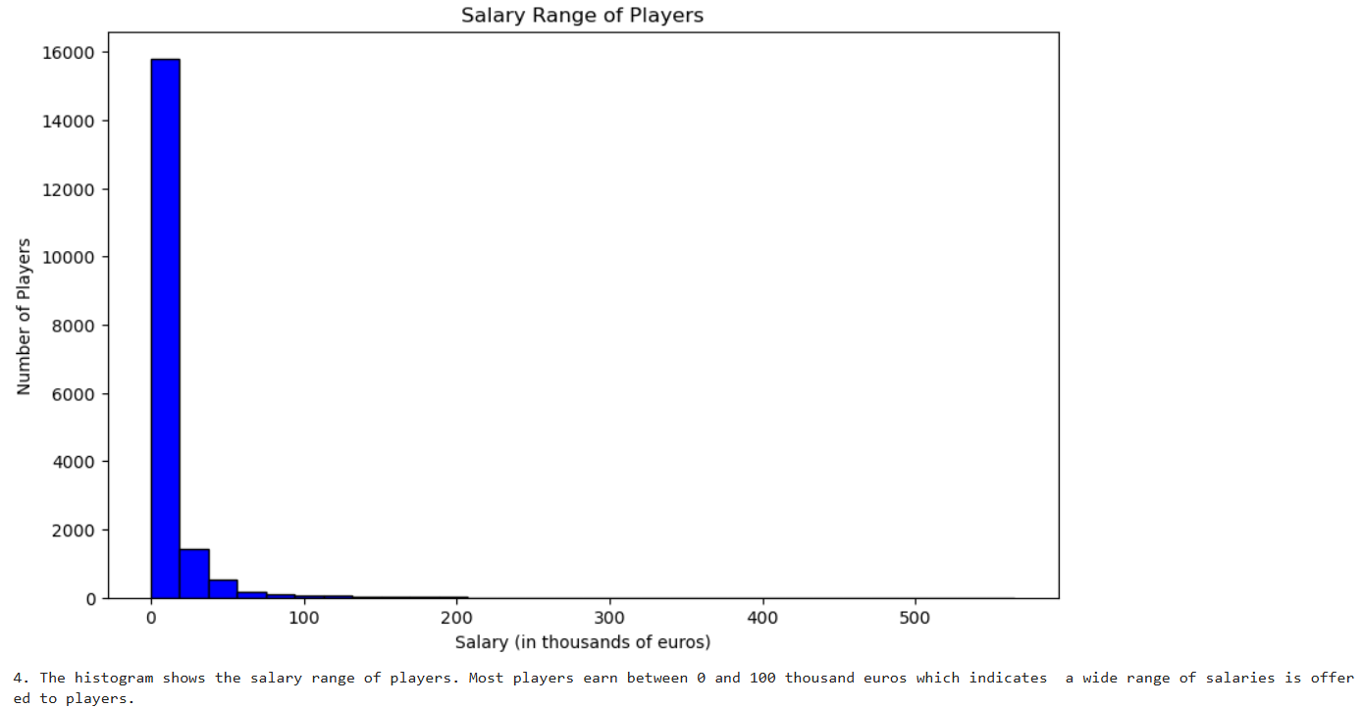

5.Who is the tallest player in the fifa? (score :1)

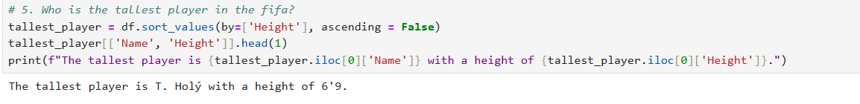

6.Which club has the most number of players? (score :1)

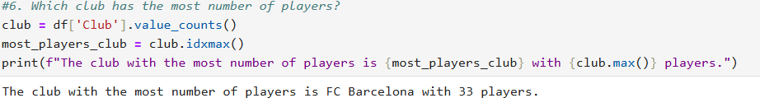

7.Which foot is most preferred by the players?Draw a bar chart for preferred foot (score :1)

